User’s Guide for the Decision Support System for Map Projections of Small Scale Data, Version 2.0

Second Draft

By Michael P. Finn and Laura N. Woodard

Open-File Report 2005-XXXX


U.S. Department of the Interior
U.S. Geological Survey
Table of Contents

Table of Contents…………………………………………………………………………i

Preface to Version 2.0……………………………………………………………………1

Background………………………………………………………………………………1

Executing the Decision Support System………………………………………………..2
The Main Page…………………………………………………………………….2
The Continental Page……………………………………………………….……..6
The Regional Page………………………………………………………………...9

The Tutorial…………………………………………………………………………..…10

Acknowledgement………………………………………………………………………12

References……………………………………………………………………………….12
Preface to Version 2.0
The major change in DSS version 2.0 is the addition of a Tutorial for the user to follow along with when making their decisions.
Included is a copy of version 2.0 user’s guide (Finn, 2003).

Background
Research geographers and applications programmers at the National Geospatial Technical Operations Center III developed this prototype Decision Support System (DSS) for selecting an optimum projection considering various factors, such as pixel sizes, aerial extent, number of categories, spatial patter of categories, re-sampling methods, and error correction methods. The design and implementation is a Web-based DSS for map projection selection. We designed the DSS for map projections of small-scale datasets (Finn, 2003).
The design includes an interactive interface to solicit information from a user and guide the user to the selection of an appropriate projection based on the input. The DSS poses questions interactively, in which the choice of the user determines the path in a decision tree to drive to a solution. The initial choice is among global, continental, or regional area coverage. The second important choice is among the preservation of shape or area, or simply a compromise (such as the Robinson projection, which is neither conformal nor equal-area) (Usery et al., 2002), (Finn, 2003). The design for version 2.0 also includes a tutorial that graphically shows the user the decision path they have chosen. It also provides access to additional information about the last decision the user made.

Executing the Decision Support System
- In order to use the DSS, please make sure that you are running the Java Run-Time Environment Version 1.4.03 or later.
      - Go to the web-based application that can be found at the following web address: http://mcsol26.er.usgs.gov/DSS/DSSAppletwbutton.html

Using the Program

The Main Page:
When you first open the Decision Support System, by opening the DSSAppletwbutton.html page, you encounter a page with the USGS logo, four drop down combo boxes, a submit button, a button to show the tutorial, two links to other pages, one being to the Java site to download the java runtime environment, and the other to the main USGS Cartographic Research web page, and the USGS standard footer (see Figure 1).

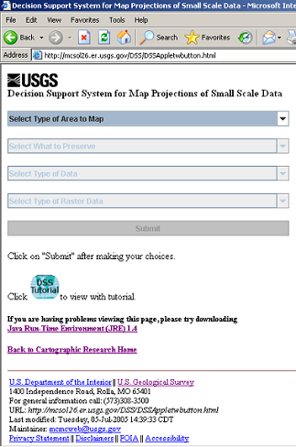

Figure 1. Startup Screen

Out of the four drop down combo boxes and submit button, the first dropdown combo box (Select Type of Area to Map) should be the only one that is editable, all the others (Select What to Preserve, Select Type of Data, Select Type of Raster Data, and Submit button) should be grayed out.

To make your first selection, click on any area of the Select Type of Area to Map drop down combo box (see figure 2).

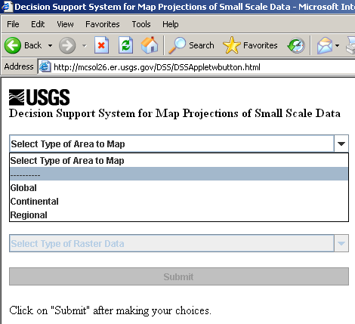

Figure 2. Type Drop Down Menu

It will display the choices of Global, Continental, and Regional. Choose one by clicking on it. If you chose Global, the next drop down combo box (Select What to Preserve) becomes editable; if you chose Continental, it will take you to the Continental Page (see page 6); and if you chose Regional, it will take you to the Regional Page (see page 9).

If you chose Global, the Select What to Preserve drop down combo box becomes editable, and to see the options you can click on any area of that box. The selections now offered are Area, Shape, and Compromise (see Figure 3).

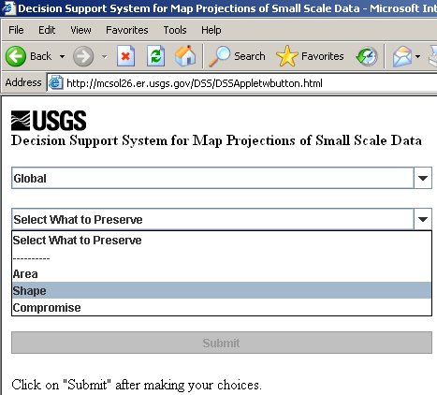

Figure 3. Preservation Drop Down Menu

Choose one of the options by clicking on it.

When an option has been selected on the Select What to Preserve drop down combo box, the next drop down combo box, Select Type of Data, will become editable. Click anywhere on that drop down combo box to see the options of Raster and Vector (See Figure 4).

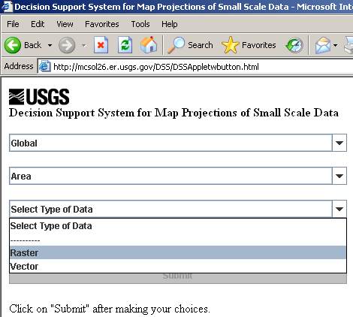

Figure 4. Data Drop Down Menu

If you chose Raster the next drop down combo box, Select Type of Raster Data, becomes editable, but if you chose Vector, the Submit button becomes clickable.

If you chose Raster data, the Select Type of Raster Data drop down combo box has become editable. Click anywhere on that drop down combo box to see the options of Continuous and Thematic (See Figure 5).

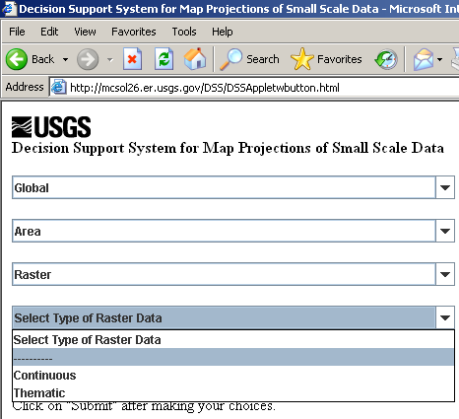
Figure 5. Raster Data Type Drop Down Menu

Once this is chosen the Submit button becomes clickable.

When the Submit button becomes clickable you should check to make sure you have the parameters that you wanted. When you are sure with your decisions, click on the Submit button and a new window will activate and display the suggested projection type based off of your choices.

The Continental Page:

If the choice of Continental was selected from the Select Type of Area to Map drop down combo box on the opening page (DSSAppletwbutton.html), the continental page will start up in the same window. It should prompt the user to make Preservation and Data Type selections in the appropriate boxes, and to click on the Continent that the user is interested in. It should also be displaying a map and three selection boxes beneath it (Preserve, Data Type, and Raster Data Type) (See Figure 6).

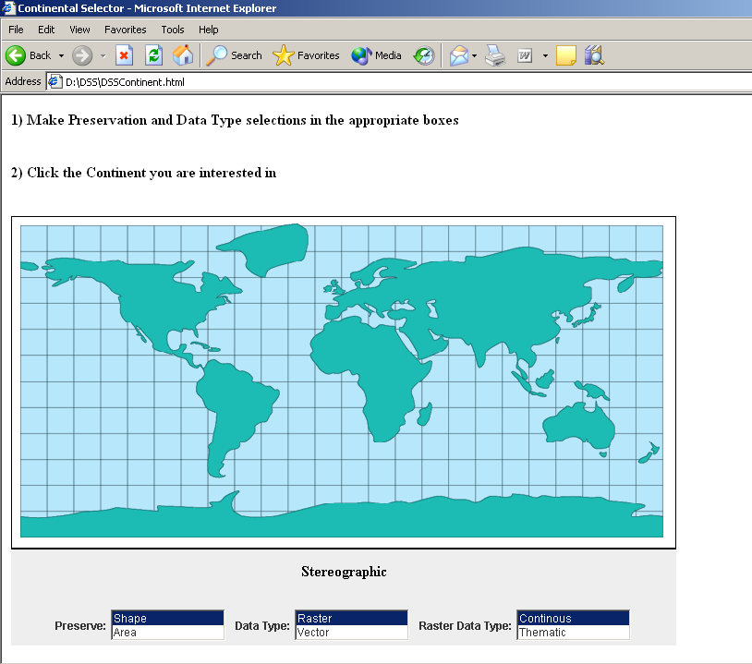

Figure 6. Continental Selector Page

The decisions in each box should be set by default to Shape, Raster, and Continuous. Decide what you want by clicking on the selection. If you choose Vector over Raster in the Data Type box, the Raster Data Type label and options (Continuous and Thematic) should gray scale out and become un-editable.

Once you have made your selections, position your cursor over the continent you are interested in. The suggested projection is shown in Real-Time on the page. When the continent that you are interested in has been clicked, the suggested projection that is displayed will turn blue and become underlined (See Figure 7).
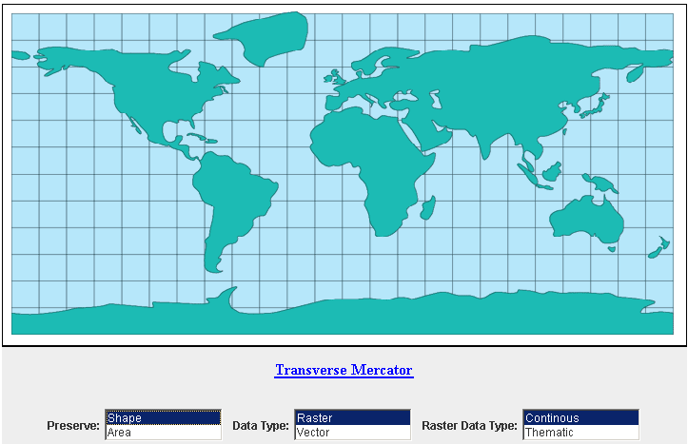

Figure 7. Projection Name Clickable

Once the suggested projection has turned blue you can position your cursor over the projection name and click it. In response a new window should activate and show more details about that particular projection.

The Regional Page:

If the choice of Regional was selected from the Select Type of Area to Map drop down combo box on the opening page (DSSAppletwbutton.html), the regional page will start up in the same window. It should prompt the user to move and resize box around the region you are interested in, and make Preservation and Data Type selections in the appropriate boxes. It should also be displaying a map and three selection boxes beneath it (Preserve, Data Type, and Raster Data Type) (See Figure 8).

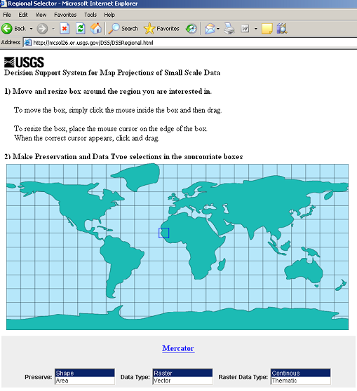

Figure 8. Regional Selector Page

The decisions in each box should be set by default to Shape, Raster, and Continuous. Decide what you want by clicking on the selection. If you choose Vector over Raster in the Data Type box, the Raster Data Type label and choices (Continuous and Thematic) should gray scale out and become un-editable.

Once you have made your selections, position and resize the box around the region that you are interested in. The projection suggested is shown in Real-Time and should automatically be blue and underlined, allowing for you to click on the suggested projection name. When you click on the suggested projection a new window should activate showing more details about that particular projection.

The Tutorial:

The tutorial will only activate when you click on the globe that is labeled “DSS Tutorial” on the opening page. Once you have clicked on that globe, the window will split showing the DSS on the top and the tutorial on the bottom. To begin with there should be four nodes showing, DSS Applet, Global, Continental, and Regional. The DSS Applet node should be green and circled in red while the other nodes (Global, Continental, and Regional) are light blue (See figure 9).

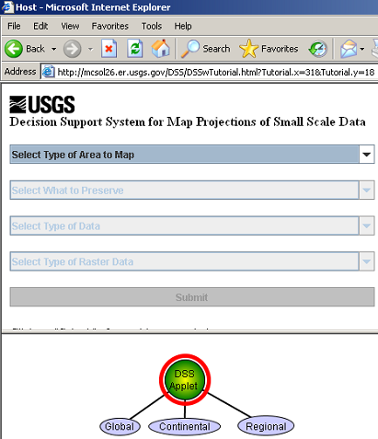

Figure 9. Opening Page with Tutorial

Only your most recent choice should be green while the rest are light blue and the red outline will show the path that your decisions have taken.

You can make your decisions the same as described above in The Main Page, The Continental Page, and The Regional Page descriptions. When a decision has been made it should be reflected in the graph shown in the tutorial (See figure 10).
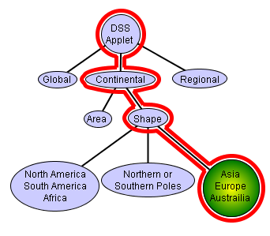

Figure 10. Tutorial Graph

At any time you can place your cursor over a green node in the tutorial and a message bubble will pop up with a small explanation of why that element is used or what it is used for (See figure 11). In each message box you can learn more about projections by clicking “more” and a new window will activate and take the user to a website with more information.

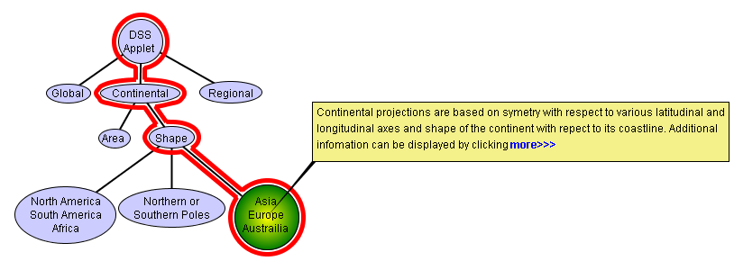

Figure 11. Tutorial Graph with More Information Popup

Acknowledgement
We are grateful to Mr. Jason Trent and Mr. James Nelson, two former USGS Computer Scientist trainees that worked on this version of the DSS. In particular, we are most grateful to James Nelson for his outstanding efforts on the tutorial and the corresponding Java development.

Reference:
Finn, M.P., Posch, S.T., (2003) User’s Guide to the Decision Support System for Map Projections. U.S. Geological Survey Mid-Continent Mapping Center, Rolla, MO.

Usery, E.L., Finn, M.P., Scheidt, D., (2002) Projecting Global Raster Databases, Proceedings Symposium on Geospatial Theory, Processing and Applications, Ottawa, Canada. International Society for Photogrammetry and Remote Sensing.

